Git & GitHub Commands
1. Basic Git Commands (For managing repositories)
- git init : Initializes a new .git repository in the current directory
- git add: To add the created files from untracking area to tracking area
“git add .” to all the files
- git commit -m “mesage”: A commit in GitHub is described as a saved change. A commit message explains what change did you perform to your project
- git remote -v: Is used to display the remote repositories connected to your local Git repository
- git remote: is used to connect your local Git repository to a remote repository like: GitHub or GitLab or Bitbucket
Syntax: git remote add <remote-name> <repository-url>

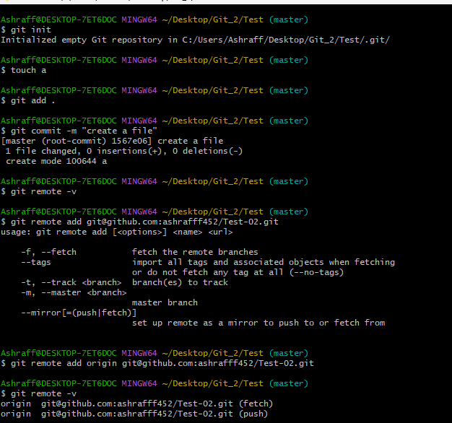
- Git push: is used to upload local Git commits to a remote repository
Syntax: git push <remote-name> <branch-name>
- Git merge: Merges changes from the specified branch into the current branch
Syntax: git merge <branch-name>
- Git pull: Is used to download and merge changes from a remote repository into your local
repository.
Syntax: git pull

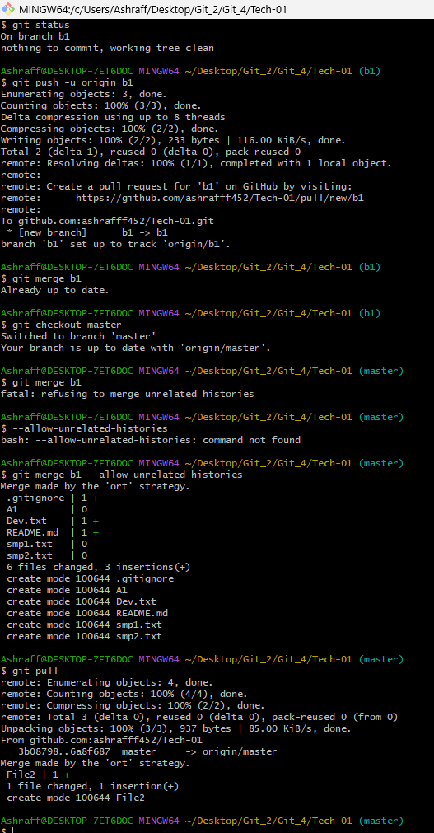

- Git fetch: Downloads objects and refs from another repository (without merging)
Syntax: git fetch
- Git clone <repo_url>: Clones a repository from a remote URL to your local machine
- Git branch: Lists all branches in your repository.

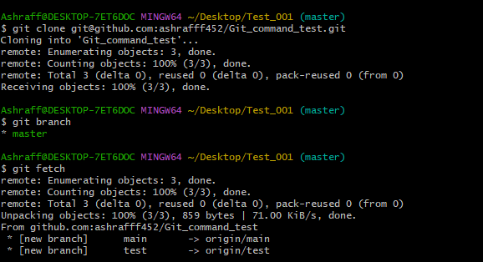
- Git diff: shows the differences between your working directory and the index (staged changes)
- Git log: shows the commit history of the repository
- Git status: shows the working directory status (which files are modified, staged, etc)
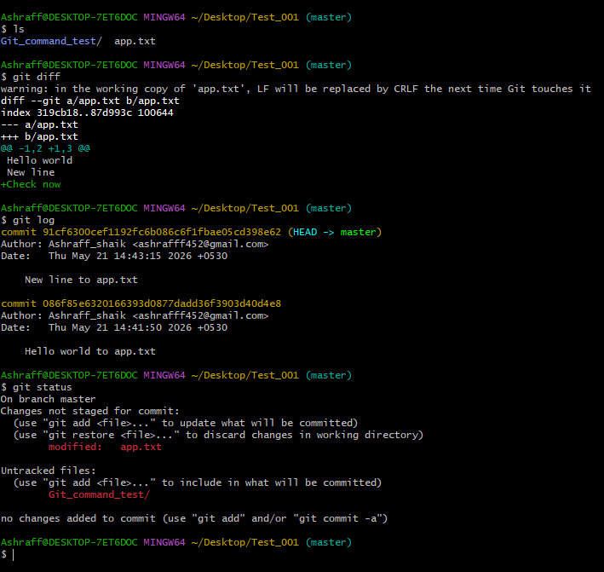
2. Branching Commands (Managing branches)
- Git branch <branch_name>: creates a new branch
- Git checkout <branch_name>: switches to an existing branch
- Git checkout -b <branch_name>: creates and switches to a new branch in one step
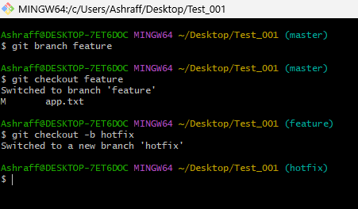
- git rebase <branch_name>: Applies changes from one branch onto another branch (instead of merging).
- git branch -d <branch_name>: Deletes the specified branch (locally).
- git branch -D <branch_name>: Forcefully deletes a branch (locally).
- git remote set-head origin <branch_name>: Sets the default branch for the remote repository.
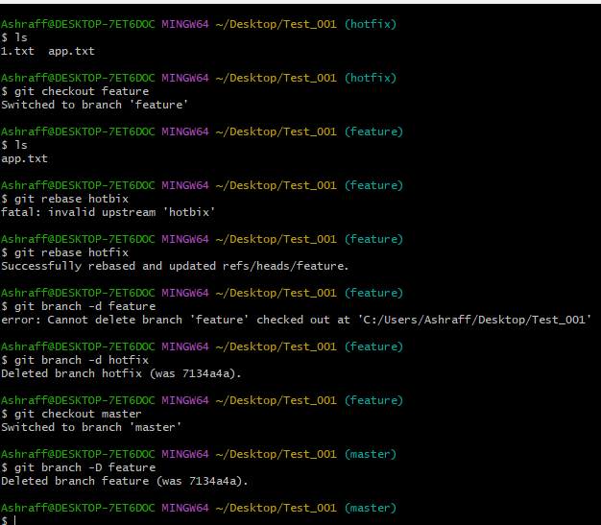
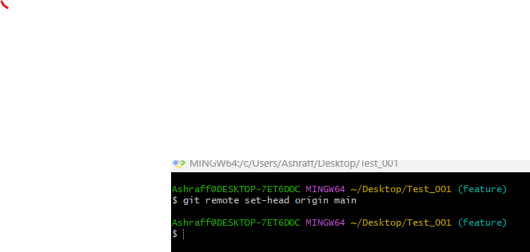
3. Remote Commands (Managing remotes and syncing with the cloud)
- git remote -v: Shows the remote repository URLs.
- git remote add: Adds a new remote repository.
  - Syntax: git remote add origin <SSH Url>
- git remote remove: Removes a remote repository.
Syntax: git remote remove origin
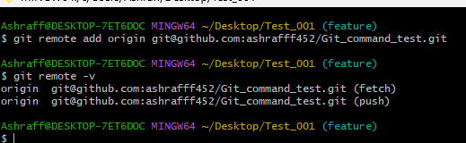
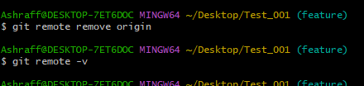

- git push origin <branch_name>: Pushes a branch to a remote repository.
- git push -u origin <branch_name>: Pushes a branch to a remote repository and sets the upstream for the branch.
- git pull origin <branch_name>: Fetches and merges a branch from the remote repository.
- git fetch origin: Downloads objects and refs from the remote repository.
- git remote show origin: Displays detailed information about a remote repository.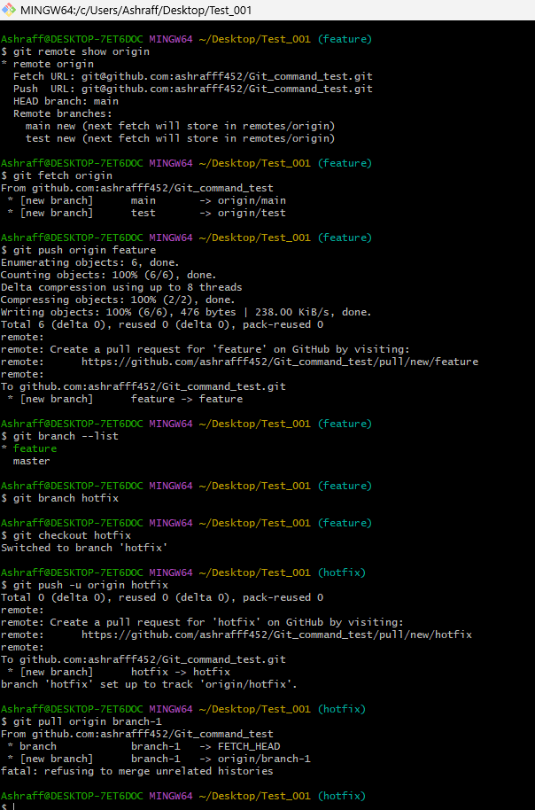

4. Staging and Committing (Managing changes)
git add .: is used to move all files from untracking area to tracking area
git add -A: is used to add all changes in the repository to the staging area.
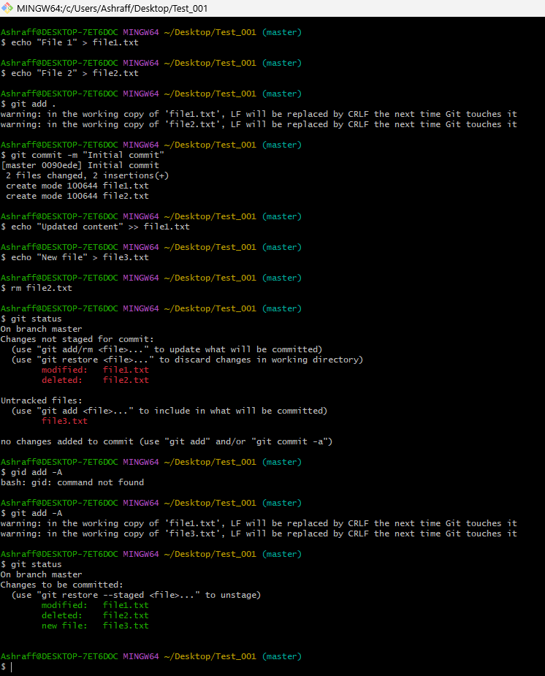

- git reset : Unstages a file (reverts it to the working directory).
- git reset --soft HEAD~1: Moves the HEAD pointer back one commit but leaves your changes staged.
- git reset --hard HEAD~1: Moves the HEAD pointer back one commit and discards changes in the working directory.

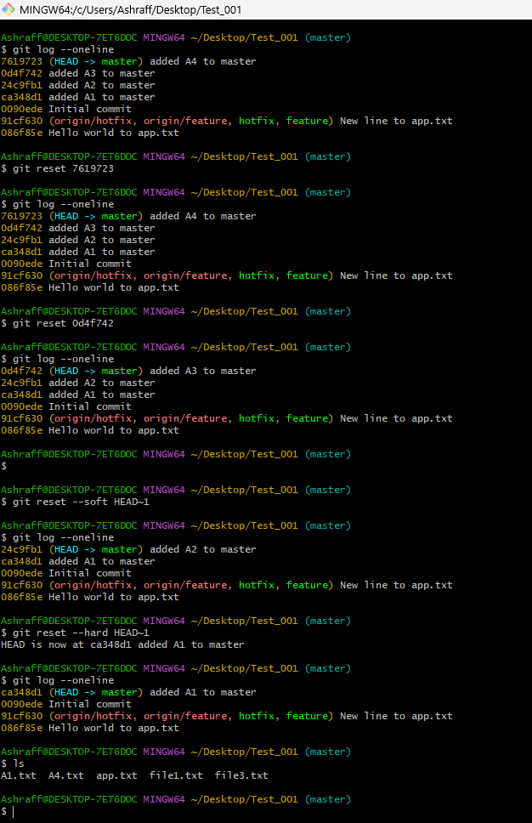

- git commit --amend: Modifies the last commit (can change the commit message or add changes).
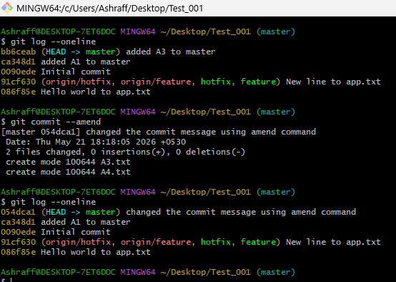

- git commit --all: Automatically stages tracked files and commits them.
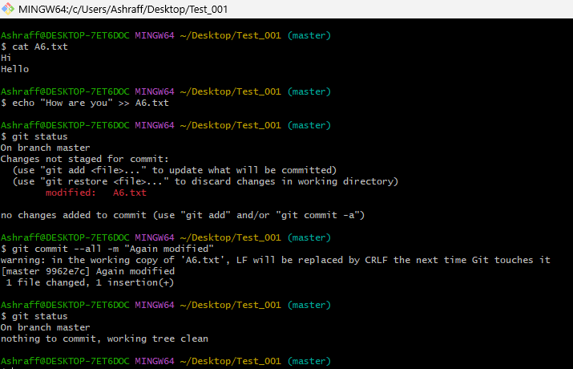

- git commit -a: Stages and commits all modified files.

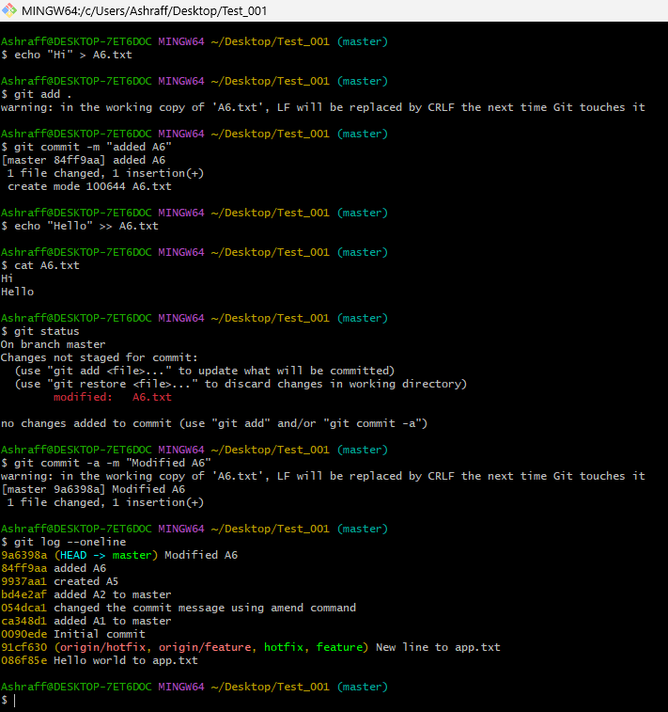

- git commit --no-verify: Skips pre-commit hooks while committing.
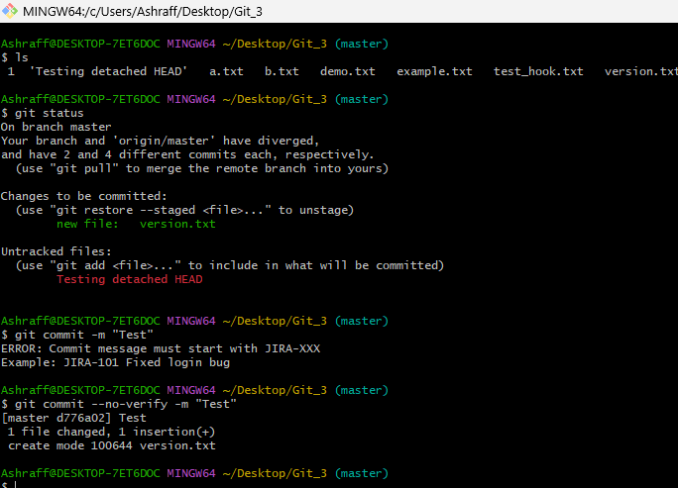

5. Viewing and Comparing Changes (Inspecting changes)

- git diff: Shows changes between your working directory and the index (unstaged
changes).

- git diff --staged: It displays changes that are already staged using git add.
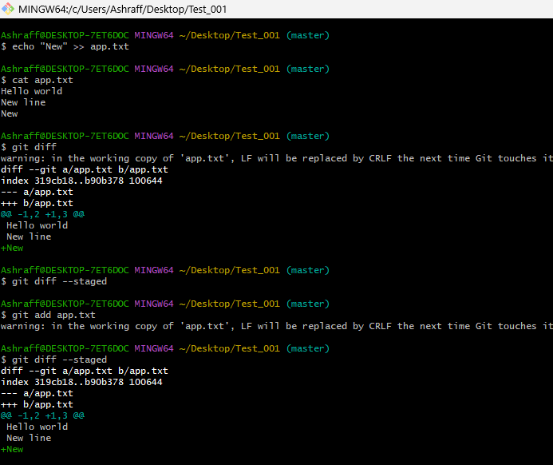

- git diff <commit_id>: Shows the differences between your working directory and a specific commit.
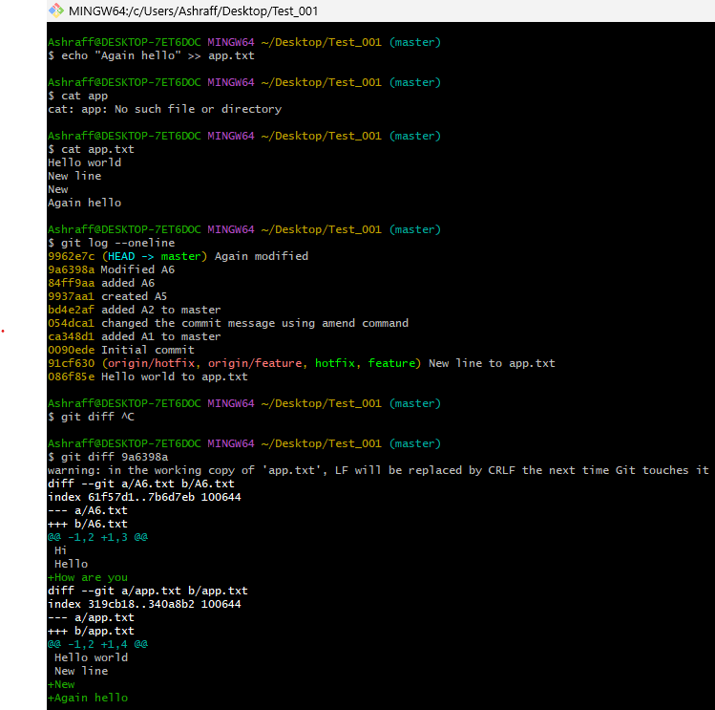

- git log: Displays the commit history.
- git log --oneline: Displays the commit history in a simplified one-line format.
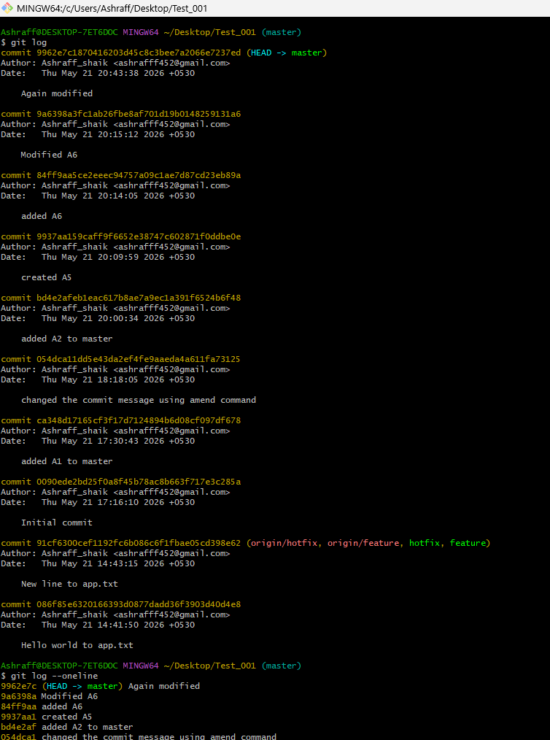
- git log --graph: Displays the commit history as a graph.
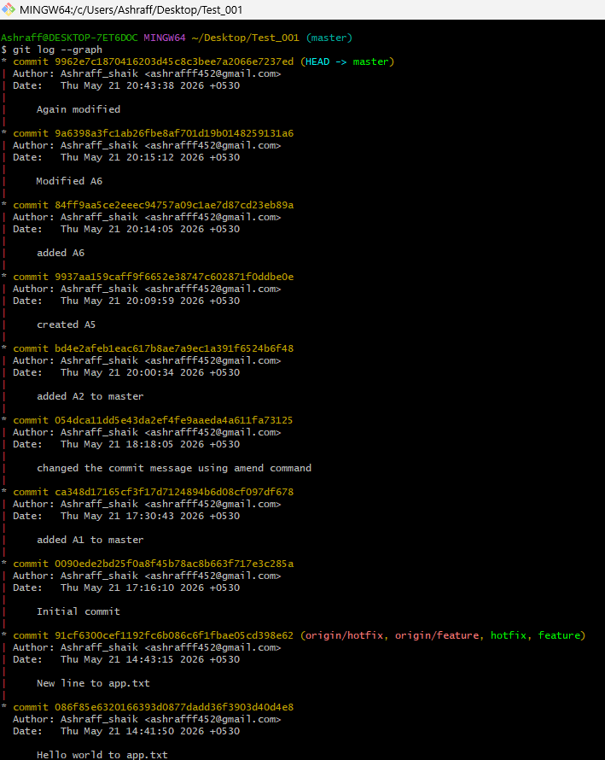

- git log --author="name": Filters commits by a specific author.
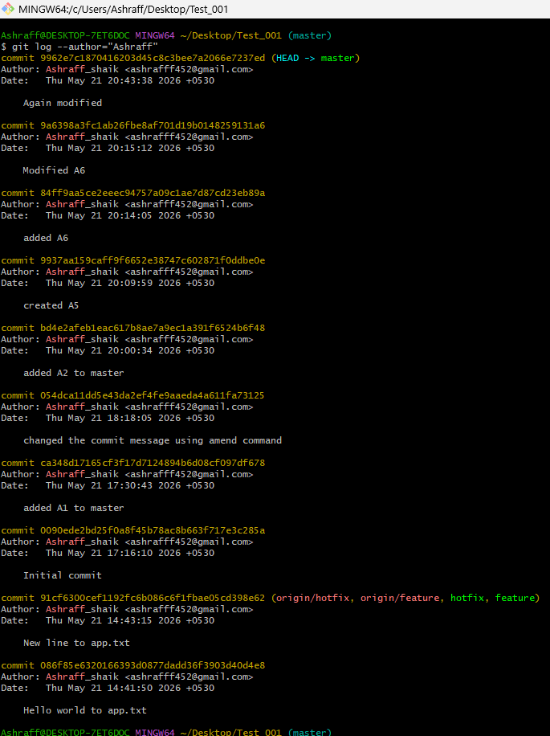
- git log --since="2 weeks ago": Filters commits made after a specific date.
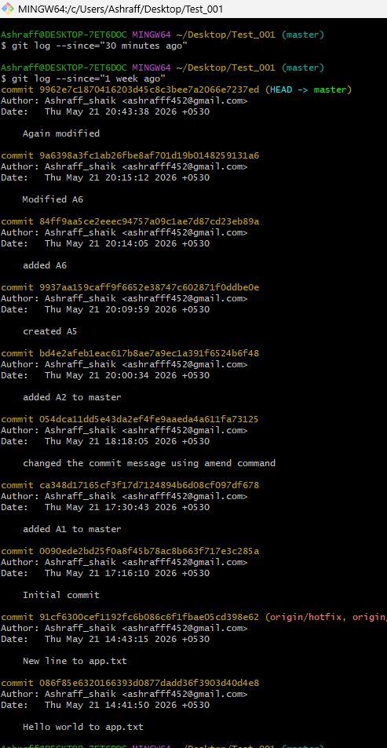
- git blame : Shows line-by-line annotations for a file, telling who last modified each line.
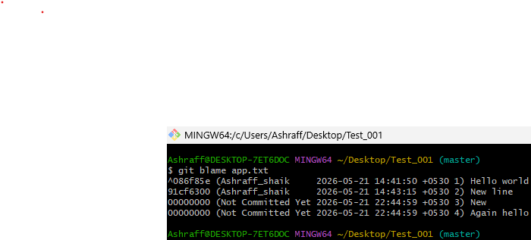
- git show <commit_id>: Shows details of a specific commit (including diff and metadata).
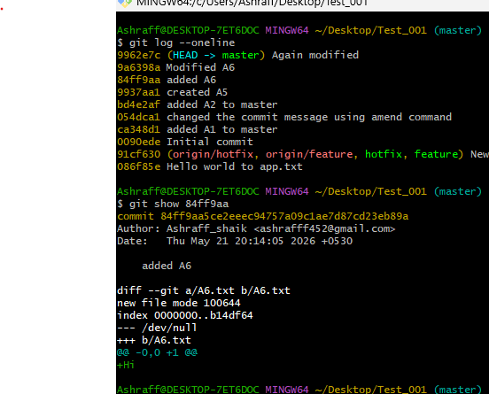

- git show <commit_id>:<file_path>: is used to display the contents of a file from a specific commit without checking out the commit.
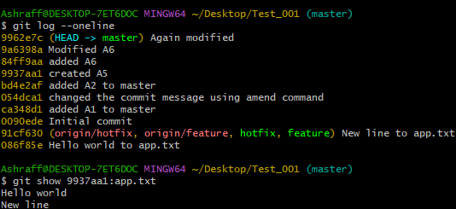

- git reset <commit_id>: Moves HEAD to a specific commit, leaving your working directory intact (can be used with --soft, --mixed, or --hard).

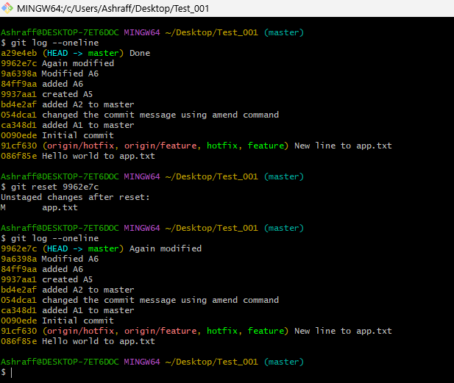

- git reset --hard <commit_id>: Resets your working directory, index, and HEAD to a specific commit (all changes will be lost).

- git reset --soft <commit_id>: Resets only the HEAD to a specific commit, leaving staged changes.
- git reset --mixed <commit_id>: Resets the HEAD and index to a specific commit but keeps the working directory unchanged. 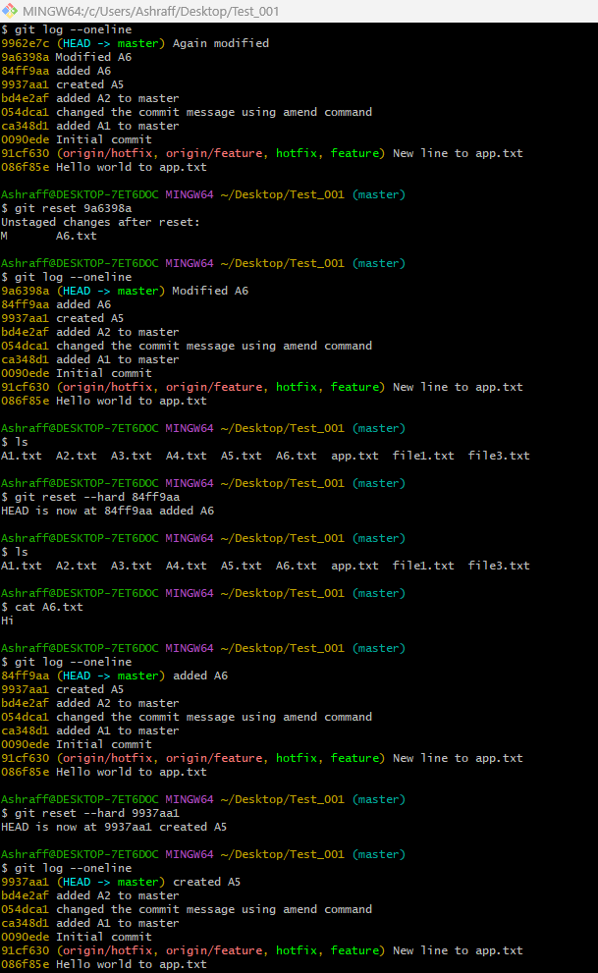

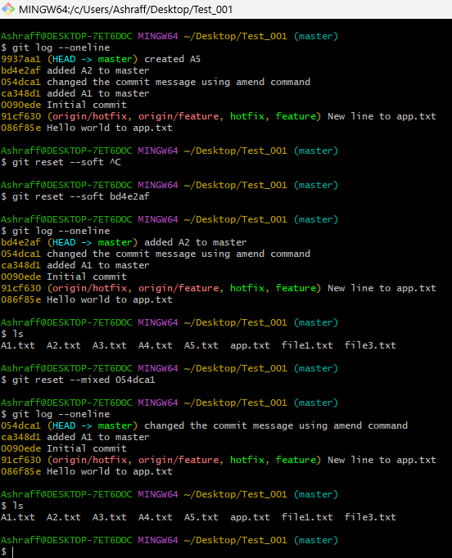
- git revert <commit_id>: Creates a new commit that undoes the changes of the specified commit.

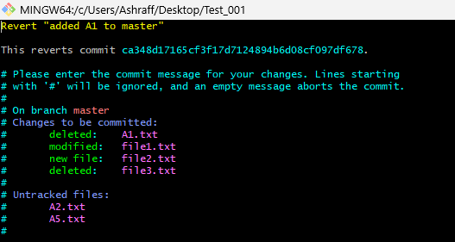
- git restore : Restores the file(s) in the working directory from the index or a commit.
- git restore --staged : Removes a file from the staging area.



- git clean -f: Removes untracked files in the working directory.
- git clean -fd: Removes untracked files and directories.

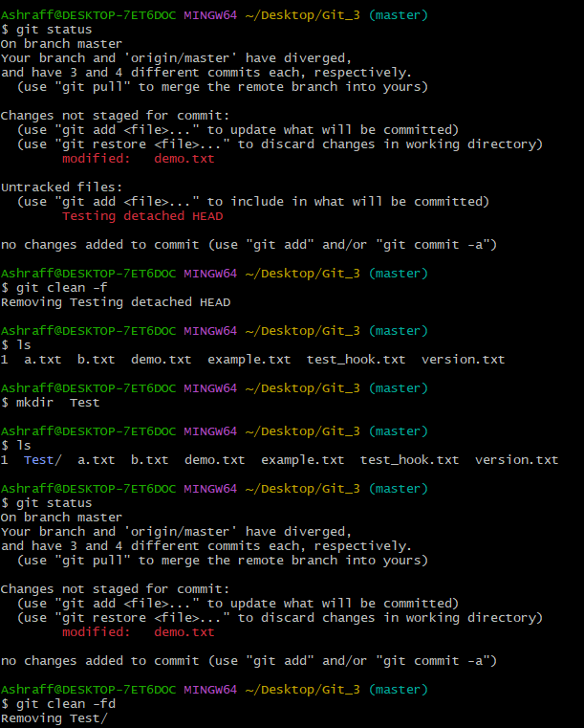

7. Stashing (Temporarily saving changes)

- git stash: Stashes the changes in your working directory (both staged and unstaged).

- git stash list: Lists all the stashes.

- git stash pop: Applies the latest stash and removes it from the stash list.

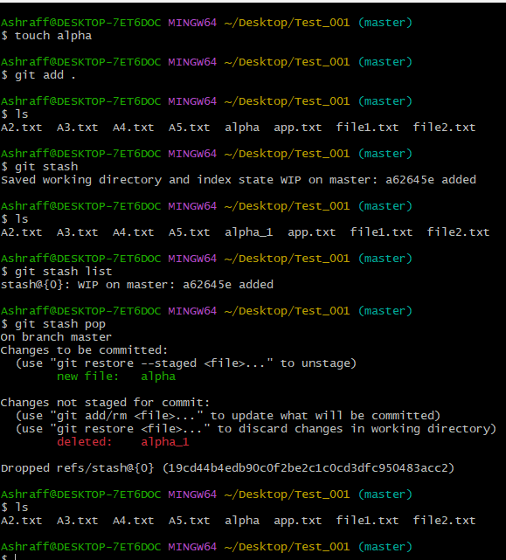

- git stash apply: Applies a stash without removing it from the list.

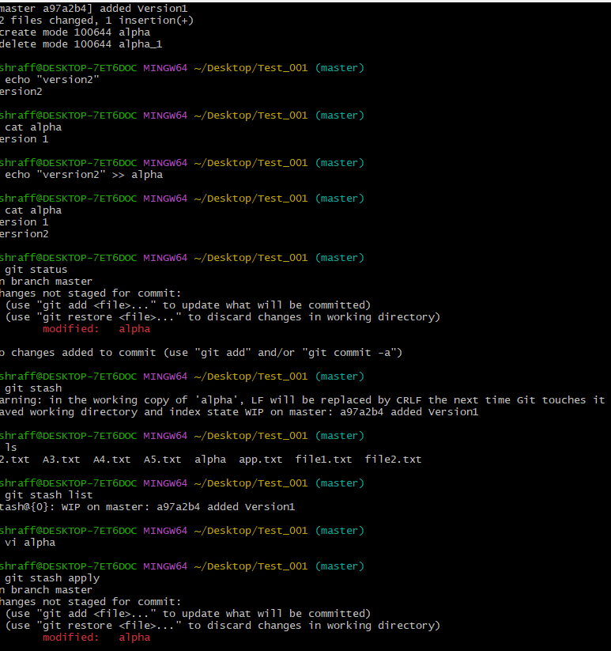

- git stash drop: Deletes a specific stash from the stash list.

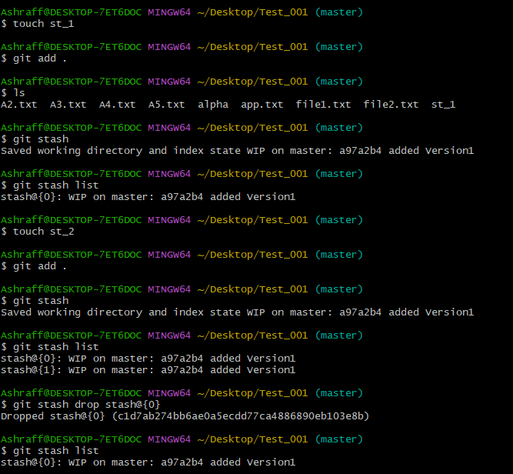

- git stash clear: Deletes all stashes.
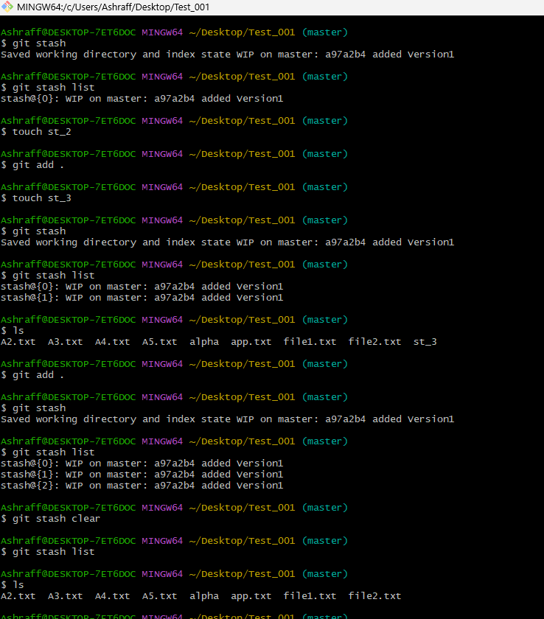
- git stash save "message": Moves the file in git stash with mentioned message.
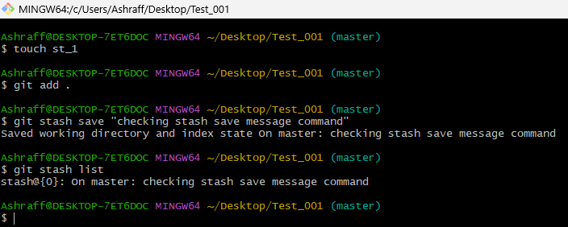
- git stash branch <branch_name>: Creates a new branch from the stash and applies it.
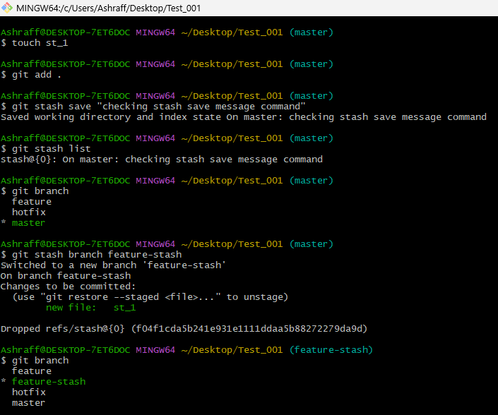
8. Tags (Managing versions)
- git tag: Lists all tags in the repository.
- git tag <tag_name>: Creates a new tag at the current commit.
- git tag -a <tag_name> -m "message": Creates an annotated tag with a message.
- git push origin <tag_name>: Pushes a specific tag to the remote repository.
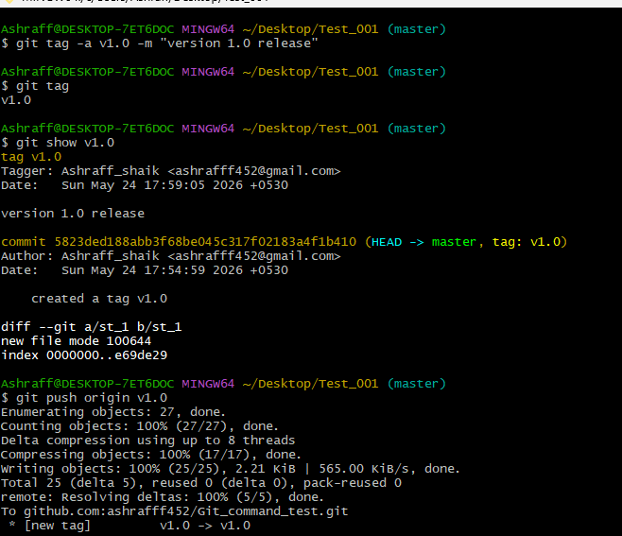
- git tag -d <tag_name>: Deletes a tag locally.
- git push origin --tags: Pushes all tags to the remote repository.
- git fetch --tags: Fetches all tags from the remote repository.
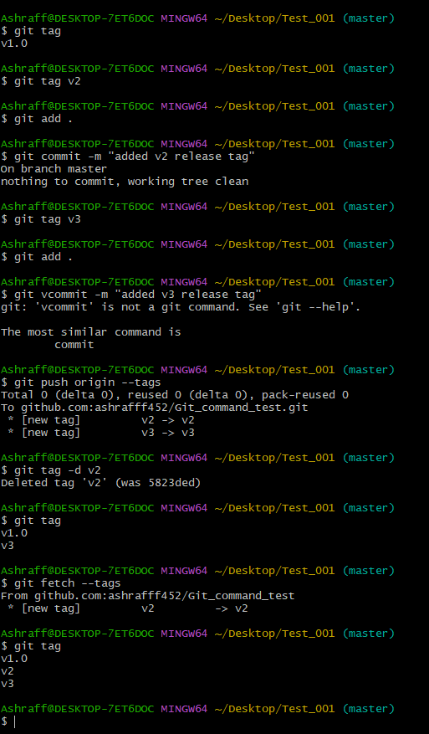
9. Git Config and Info (Configuration and repository information)

- git config --global user.name "Ashraff_Shaik": Sets your global username for commits.
- git config --global user.email"ashrafff452@gmail.com": Sets your global email for commits.
- git config --list: Lists all configuration settings.
- git config : Sets a specific configuration option.
- git config --global core.editor : Sets the default text editor for Git.
- git config --global color.ui true: Enables colored output in Git.
- git config --global alias.st status: Creates a custom Git alias (e.g., git st for git status).

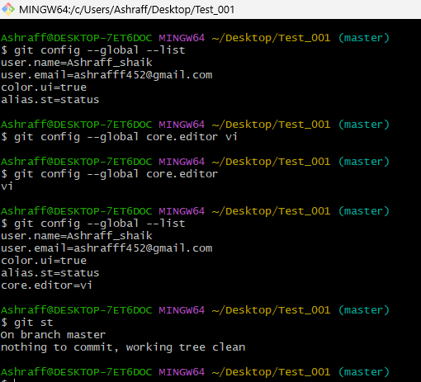

10. Git Aliases (Custom commands)
- git config --global alias.<alias_name> <actual_command>: Creates a new Git alias for an existing command.
    - Example: git config –global alias.co checkout
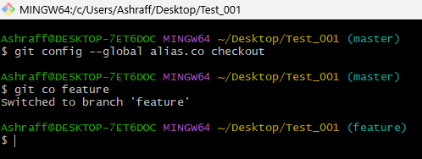

11. Git Hooks (Automated scripts triggered by Git actions)
- git init: Creates a .git/hooks directory, where hook scripts are stored.
- git commit-msg: A hook that runs before a commit message is saved (you can use this to enforce message formats).
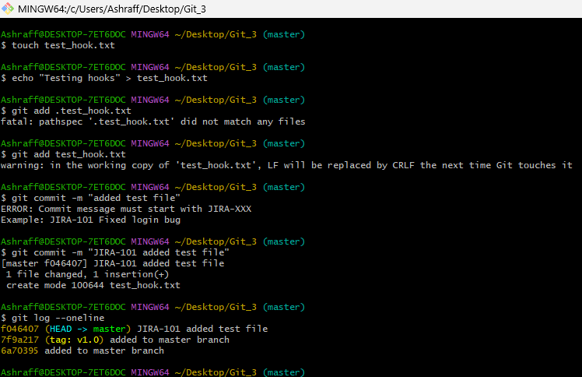

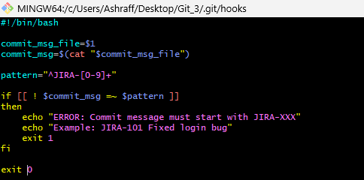
- git pre-commit: A hook that runs before a commit is made (can be used for checks like linting).
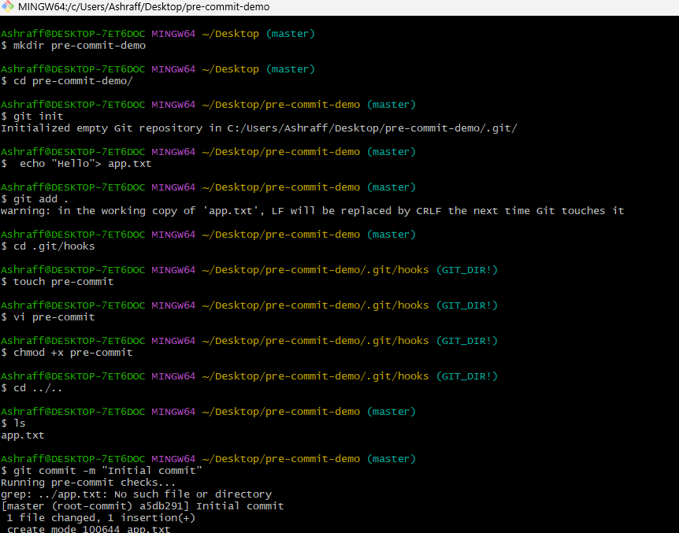

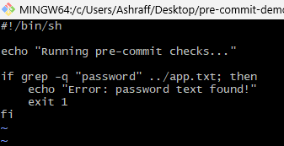

- git post-commit: A hook that runs after a commit is made.
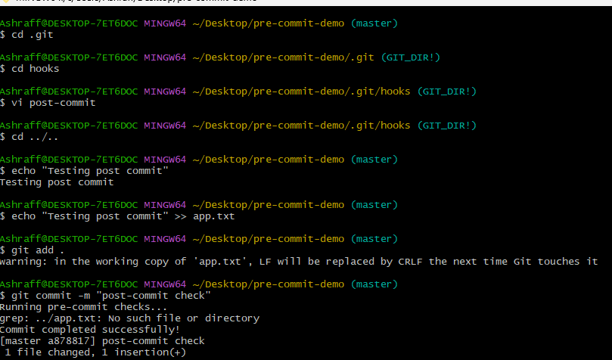
12. Git Submodules (Managing external repositories within a project)

- git submodule add <repo_url> : Adds a new submodule to the repository (downloads an external repo).
- git submodule init: Initializes the submodules configured in the repository (after cloning).
- git submodule update: Updates the submodules to the commit specified in the superproject.
- git submodule status: Displays the current commit of the submodule.
- git submodule deinit : Removes a submodule from the working directory.
- git submodule update --remote: Updates the submodule to the latest commit from the remote repository.

